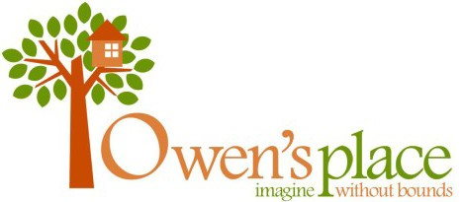

***Owen’s Place Sports Baseball & Kickball***

As we look forward to the upcoming Baseball and Kickball season we are taking strides to enhance the safety and learning atmosphere for all kids who partake in America's favorite pastime.

Approximately 50% of our revenue is collected through registrations. We need to have the support of our sponsors and community donations to provide us with the remaining portion of our yearly budget to provide the necessary access for those with a disability to play both baseball and kickball.

Owen’s Place Sports Baseball and Kickball continues to be a huge part of the community and will assist in the continued creation of the overall Owen’s Place Park. We would like you to support us with your sponsorship/contributions to help keep this program running and growing. We are a 501(C) (3) non-profit corporation, and your contributions are tax deductible.

These are the categories of sponsorship/contribution available:

* $150-Sponsor a team. Your name will be placed on the team's uniforms
* $100-Provides advertising on a diamond's backstop.
* $35-Sponsor a child in need

We hope to see everyone at Owen’s Place Park to watch our children play ball!

Any questions, call Gregg Gustafson @ 208-590-3310 or [owensplacebaseball@gmail.com](mailto:owensplacebaseball@gmail.com) or

<http://www.owensplace.org> or <https://www.facebook.com/owensplace>

- - - - - - - - - - - - - - - - - - - - - - - - - - - - - - - - - - - - - - - - - - - - - - - - - - -

Detach along line and mail fees/donations to

**Owen’s Place Sports**

**P O Box 115**

**Alpha, OH 45301**

Business Contact Person Phone Email

Business Sponsor wishes to:

Sponsor a team ($150)

Advertise on a diamond backstop ($100)

Sponsor a child in need ($30)

Provide donation of $ to Owen’s Place Sports Baseball for equipment or park expansions.